**Learn in Community**

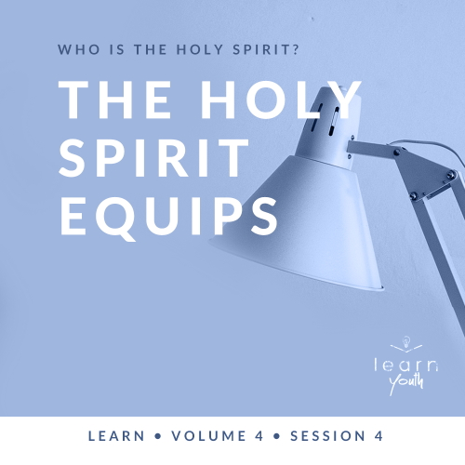

Small Group Study

**Volume Overview**

**Who is the Holy Spirit?**

But the Holy Spirit produces this kind of fruit in our lives: love, joy, peace, patience, kindness, goodness, faithfulness, gentleness, and self-control. There is no law against these things! ([Galatians 5:22–23](https://ref.ly/logosref/Bible.Ga5.22-23))

*When it comes to God, we frequently think about and discuss God the Father and God the Son. The concept of God as our Heavenly Father and Jesus’ life on earth are generally easy to understand. However, Scripture makes it clear that the Holy Spirit is equally God. Through these sessions, we’ll look at the following questions: Who is the Holy Spirit? What role does the Holy Spirit play in our life? What can we learn about the nature and ways of God through what Scripture tells us about the Holy Spirit? How does the Holy Spirit help me in my faith? God living within us can empower us, help us grow, and equip us in a unique way that God among us could not*.

|  |
| --- |
| ***You Will Need***   * *Blindfolds, one per team* * *Random obstacles that work in your space (e.g., garbage cans, pillows, coat racks, etc.)* * ***My Spiritual Gifts*** *page, one per student*   ***Getting Ready***   * *Set the obstacles randomly around the room.* * *Print copies of the* ***My Spiritual Gifts*** *page, one per student.* * *First time leading* Learn *for Youth? Look here for the* [*Facilitator Guide*](https://0b769b0ed3569ef9d18b-f88d8272f61086866d50d048b43ef630.ssl.cf2.rackcdn.com/sites/biblengagementproject/Listen_Facilitator_Guide.pdf)*.*   *To access session content and videos from a computer, visit:*  [***BibleEngagementProject.com/downloads***](https://bibleengagementproject.com/downloads) |

**Engage**

**Welcome**

*Take this time to welcome everyone, introduce new students, learn names, and thank everyone for coming*.

|  |
| --- |
| **QUESTION**  What’s your greatest talent? |

|  |
| --- |
| **QUESTION**  Does anyone want to share something they’re awful at doing? |

**Opening Prayer**

*Prayer thoughts: Thank the Lord for the talents the students mentioned. Also, thank Him for the areas where we aren’t as talented. Thank the Lord for the uniqueness of talent He gives to His Church. Ask the Holy Spirit to be present to reveal how He has equipped the students to serve others*.

**Introduction**

In our time together today, we’ll discuss how the Holy Spirit equips us to serve God. Part of becoming like Jesus is being effective at revealing His goodness to others and leading them into relationship with Him. The Holy Spirit is able to equip you to fulfill your true purpose.

**Group Activity**

**Learn to Listen**

|  |
| --- |
| ***You Will Need***   * *Blindfolds, one per team* * *Random obstacles that work in your space (e.g., garbage cans, pillows, coat racks, etc.)*   ***Getting Ready***   * *Set the obstacles randomly around the room.* |

To be ready for the Holy Spirit to equip us, we need to focus on listening and obeying. So let’s play a game that tests those skills. We’ll form two teams and go through an obstacle course. Each team will have one designated caller who gives instructions. The rest of the team will take turns wearing a blindfold one at a time.

When it’s your turn, you’ll listen to the instructions of the caller. The objective is to navigate through the obstacles without touching them. If you touch an obstacle, you must start over. The first team who has everyone successfully navigate the obstacles wins.

• *Depending on your group size and room size, you may want to choose a smaller number of students to participate*.

|  |
| --- |
| **QUESTION**  What are a few things we can learn from this game? |

|  |
| --- |
| **QUESTION**  Why was it important to listen carefully to the caller? |

Like the caller in this game, the Holy Spirit is the most important Voice in our life. He helps us navigate the world around us. He not only helps us avoid obstacles, but He also shows us the right direction to go. He speaks specifically to you and me on an individual basis. He equips us, helping us to be effective. Let’s watch the video to hear more about Him.

**Watch**

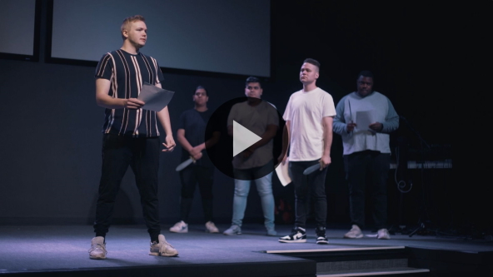

**Consider What the Bible Says**

*Ensure each student has access to a Bible, preferably the same version*.

We’re going to look at a couple of different Scriptures together in order to better understand how the Holy Spirit equips us for life and ministry.

**The Holy Spirit Inspires Us to Take Action**

Read [Acts 8:26–31](https://ref.ly/logosref/Bible.Ac8.26-31).

In this story, we get to watch as the Holy Spirit spoke to a believer named Philip. As a result of Philip’s quick obedience, someone heard the good news about Jesus.

|  |
| --- |
| **QUESTION**  What instructions did the angel and the Holy Spirit give to Philip? |

|  |
| --- |
| **QUESTION**  Have any of you ever felt like the Holy Spirit was giving you instructions? If so, what happened? |

Have you ever considered that other people are depending on our willingness to listen to the Holy Spirit and obey His directions? Our relationship with the Holy Spirit matters to others. There’s someone out there who will one day need your obedience in order to make it in this life just like the man in today’s Bible story. Let’s find out what happened as a result of Philip’s obedience.

**The Holy Spirit Directs Us to Places We Can Serve**

Read [Acts 8:32–35](https://ref.ly/logosref/Bible.Ac8.32-35).

|  |
| --- |
| **QUESTION**  What do you think would have happened if Philip didn’t hear and obey the Holy Spirit’s direction? |

The Holy Spirit doesn’t waste time with us. If He’s speaking, we can be sure it’s important. We need to mirror Philip’s actions—listen and obey. This next question will be a little tougher, but it’s worth discussing.

|  |
| --- |
| **QUESTION**  Has there ever been a situation when you didn’t listen to and obey the Holy Spirit? What happened? |

In this passage, we see that Philip knew the Bible well enough to share the good news. He was prepared when the opportunity presented itself.

|  |
| --- |
| **QUESTION**  Do you feel prepared for opportunities like Philip? Why or why not? |

Let’s keep reading this story to see how it ends.

Read [Acts 8:36–40](https://ref.ly/logosref/Bible.Ac8.36-40).

We see that the Ethiopian responded to the good news and was baptized. We don’t always get to see someone respond to what we share, but that day Philip did. Before we discuss that further, let’s jump to the unusual ending.

|  |
| --- |
| **QUESTION**  What happened to Philip at the end? What do you think that means? |

|  |
| --- |
| **QUESTION**  Has God ever done a miracle in your life or through your life? Tell us about it. |

Certainly, being transported from one place to another by the Holy Spirit is an amazing miracle. However, often people get too focused on that part of this story. Everything that happened before this was also miraculous. It might not have seemed as spectacular, but obedience, God’s timing, and going from stranger to being baptized are significant too.

|  |
| --- |
| **QUESTION**  Have you ever felt like you were in the right place at exactly the right time for God to use you? What happened? |

**The Holy Spirit Equips Each Person Uniquely**

|  |
| --- |
| **QUESTION**  Is there a specific way, place, or ministry you feel the Holy Spirit is directing you to serve? |

We’re going to move to a different passage of Scripture that talks in more detail about being equipped by the Holy Spirit. Let’s look at some of the specific spiritual gifts that are mentioned in the Bible.

Read [1 Corinthians 12:7–11](https://ref.ly/logosref/Bible.1Co12.7-11).

|  |
| --- |
| **QUESTION**  Who distributes these gifts? Why is that important? |

|  |
| --- |
| **QUESTION**  What spiritual gifts are mentioned? |

|  |
| --- |
| **QUESTION**  Why do you think the Holy Spirit gives different kinds of gifts like these? |

|  |
| --- |
| **QUESTION**  Have you operated in a spiritual gift or heard someone minister through one of these gifts? Share your experience. |

The diversity of gifts in the Bible tells us that God wants to use more than one person to share the good news and minister to others. He wants every believer to utilize their gifts. When we put the help of the Holy Spirit into action, we can more effectively serve others. The Holy Spirit equips us to minister together as a church family.

**Did You Know?**

|  |
| --- |
| From the days of the Jewish king Manasseh until the destruction of Solomon’s Temple in 586 BC, a large population from Jerusalem relocated to parts of Africa. Most notably, they lived in an area known as Elephantine, which was on the border of Egypt and ancient Ethiopia (not in the same location as Ethiopia today). At Elephantine, the Jewish settlers built a new temple to God and began sharing their faith in the region. This resulted in an expansion of Ethiopian Judaism. These Jews, possibly like the Ethiopian official from today’s story, made pilgrimages to Jerusalem for the most important religious holidays. |

**Reflect**

**The Holy Spirit Equips**

From these two passages of Scripture, we can see how the Holy Spirit equips us for ministry. To be fully equipped, we must listen for the voice of the Holy Spirit and walk in obedience to His leading like Philip did. We also should seek the insight of the Holy Spirit about what spiritual gifts we may have been given for the purpose of serving others.

Philip’s example also shows us how important it is to embrace the fact that God does miracles. Often those miracles are directly linked to our obedience and the gifts He has given us. It’s so exciting to know that we have the privilege of partnering with God in His mission to share the good news about Jesus with others.

**Listen to God**

Let’s take time to consider how we can allow the Holy Spirit to equip us. These questions are meant to serve as a conversation between you and God. Sharing your responses with the group is completely voluntary.

• *Pause for a few moments of silent reflection before asking students if they want to share*.

|  |
| --- |
| **QUESTION**  Knowing the Holy Spirit equips you to serve, what’s one way you can start using your gifts to serve right now? |

|  |
| --- |
| **QUESTION**  What’s a need in our church that the Holy Spirit might be leading someone to serve in? |

**Activate**

It’s so important to be not only hearers of the Word, but people who put God’s Word into action. The Holy Spirit will help us to live out that truth.

• *Distribute copies of the* ***My Spiritual Gifts*** *page to the group*.

Let me challenge you to look through this list of spiritual gifts carefully. See if any stand out to you as something the Holy Spirit may have nudged you toward. Then take some time to pray about how God may want to use you in one or more of these ways.

**Conclusion**

God has plans for your life! He created you with a purpose in mind. He wants to work through you to change the world. The best part is that He is already equipping you to accomplish the task.

In order to fulfill His plans, we must learn to listen to and obey His Holy Spirit. We should also have conversations with our spiritual leaders, so they can help us discern what gifts the Holy Spirit has given us. Ultimately, we can be confident in this: The Holy Spirit will equip us to fulfill God’s intentions for our life.

|  |
| --- |
| **Salvation Opportunity**  *Include this if you think there may be some in the group who do not have a personal relationship with Jesus.*  In today’s Scriptures, we read about how an Ethiopian official was saved. It’s important to see the bigger picture. God loved the Ethiopian official so much that He sent Philip to him so he could experience the good news of Jesus. God’s love goes even further than that. Because God had spent time preparing Philip, he was ready for that encounter with the Ethiopian official. God cares for you in the same way. He brought you here because He loves you that much.  **Is there anyone here that we can pray for who doesn’t have a relationship with Jesus or wants to renew their relationship with Him?**  *Take a moment to acknowledge those who respond, and thank them for their desire to make things right between themselves and God. Pray with them as we close in prayer or after the group time is over. Following group time, talk more about where they are in their walk with God and how you might be able to help.* |

**Prayer**

Father, we understand that You have given us everything we need in order to walk in Your plans for us. We’re grateful for the Holy Spirit, the Giver of spiritual gifts and the One who directs our steps. We choose today to be obedient, so we can always be in the right place at the right time. We do this because we love You and because we love people. Teach us how to use our gifts. Teach us how to hear Your voice. We want You to lead our life. Amen.

Be sure to work through the personal devotions provided for you on the app. These will help you develop an ear to hear God.